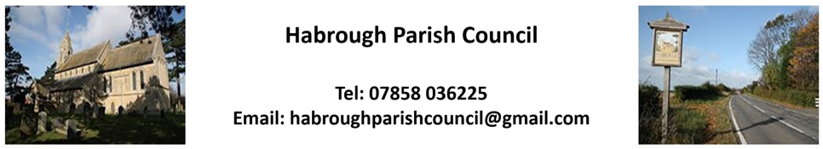

To All Habrough Parish Councillors:

You are summoned to a meeting of Habrough Parish Council on Monday 3rd February 2025 at the Village Hall, Habrough at 7.30pm

Mr S. Brookes
Clerk to Habrough Parish Council – 26.01.2025

The meeting will have a period of public consultation which shall not exceed 20 minutes in total. The public can speak on items contained on the Agenda below or on other issues of concern, although if these are not scheduled Agenda items the Council may have to carry the item and/or any action to the next meeting.
Note that the recording of meetings is allowed but only through prior notification to the chairman and/or the clerk before the meeting commences and must be in accordance with the council’s adopted policy for such.

AGENDA
25/11 To receive and accept apologies for absence
Apologies from –

25/12 DECLARATIONS OF INTEREST (Code of Conduct 2020) –
- To record declarations of interest by any member of the council in respect of the agenda items
listed below. Members declaring interests should identify the agenda item and type of interest being declared.

- To note dispensations given to any member of the council in respect of the agenda items listed
below.

25/13 Minutes
To approve minutes of the last meetings from 6th January 2025

25/14 Reports by Ward Councillors

To receive brief reports from the Ward Councillors representing Habrough and the local community.

25/15 Highways/Footpaths/Traffic Issues
- To receive any updates on recent issues, receive any highways/footpaths matters and
agree any necessary actions

25/16 Planning Matters
Planning Consultation Ref: DM/0923/22/FUL ( for information )

25/17 Reports
To receive reports from:
- ERNLLCA
- Police Report

25/18 Parish Council Matters
- To receive updates on casual vacancies and agree to any actions.

25/19 Finance
- To receive Bank Statement and Bank Reconciliation for October & November

- To approve any December payments

25/20 Future Dates
- Next Parish Council Meeting – Monday 3rd March 2025
Councillor M. Jones gave apologies for not being able to attend

- To receive any other future dates.

Meeting closed at 20.20hrs
S.B,/26.01.2025

