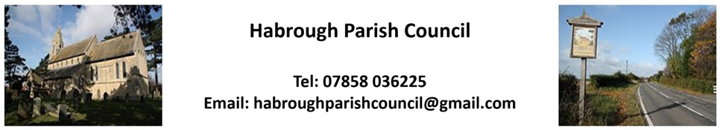

Habrough Parish Council meeting on 6th January 2025
Agenda

25/01 To receive and accept apologies for absence
Apologies from - Cllr J Keyworth – Family business

25/02 DECLARATIONS OF INTEREST (Code of Conduct 2020) –
- To record declarations of interest by any member of the council in respect of the agenda items
listed below. Members declaring interests should identify the agenda item and type of interest being declared.

- To note dispensations given to any member of the council in respect of the agenda items listed
below.

25/03 Minutes
To approve minutes of the last meeting from 6th January 2025

25/04 Reports by Ward Councillors
To receive brief reports from the Ward Councillors representing Habrough and the local community.

25/05 Highways/Footpaths/Traffic Issues
- To receive any updates on recent issues, receive any highways/footpaths matters and
agree any necessary actions

25/06 Planning Matters

25/07 Reports
To receive reports from:
- ERNLLCA - None Received

- Police Report - Distributed by email with agenda

25/08 Parish Council Matters
- To receive updates on casual vacancies and agree to any actions.

25/09 Finance
- To receive Bank Statement and Bank Reconciliation for October, November and December
- To approve any January payments

25/10 Future Dates
- Next Parish Council Meeting – Monday 3rd February 2025
- To receive any other future dates.
Acceptance of J. Pepers signed Acceptance of Offer for Councillor

S.B,/27.01.2025

