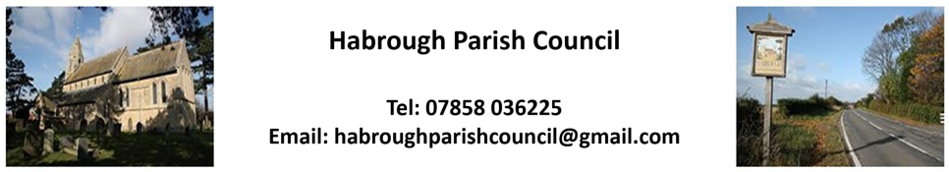

Minutes of meeting on 3rd March 2025
25/21 To receive and accept apologies for absence
Apologies from - Cllr Marie Jones and Ward Cllr’s Karen and Stewart Swinburn
Resolution - Accepted
In Attendance - Cllr J. Keyworth, Cllr A. Pagram, Cllr O. Razvaran, Cllr J.Peper

25/22 DECLARATIONS OF INTEREST (Code of Conduct 2020) –
- To record declarations of interest by any member of the council in respect of the agenda items
listed below. Members declaring interests should identify the agenda item and type of interest being declared.

- To note dispensations given to any member of the council in respect of the agenda items listed
below.

None Declared

25/23 Minutes
To approve minutes of the last meeting from 3rd February 2025
Resolution – Agreed and Accepted
25/23 Visit of Sam Matthews
To bring us up to date regarding the Data Centre Development
There were a number of local residents ( and those in the nearby vicinity ) who attended the meeting, hoping to find out more about the development ( 12 in total ).
Sam stated that Planning Permission in Principle was granted in August 2024. Currently they are working on the detailed plans with a Major Tech Firm ( he cannot divulge who that is at this moment in time ) but he will keep us updated regarding the progress of the application procedure.
Once the detailed plans have been submitted, then there will be time to raise objections or put in comments in relation to everything.
People were asking questions about the noise abatement, water and electricity supply, routes for vehicles, appearance etc but due to the plans only being in the Principal stage he was unable to give specific answers to those requested.
Sam will be happy to attend another meeting once the detailed plans have been submitted and then he will be able to say more about the development.
Cllr Keyworth stated that although the Data Centre will not be built in Habrough Parish, we should still be informed of developments as I will be adjacent to our boundary and may have an impact on the village.

25/25 Reports by Ward Councillors
To receive brief reports from the Ward Councillors representing Habrough and the local community.
Cllr Croft re-iterated that the ‘Hole Fund’ was now back in operation and that they should be reported to the council who will check the depth to see if they reach the criteria ( 40mm depth ).
Cllr Keyworth stated that she has reported the hole on the bridge.
Discussion was had about the road to the big park regarding possible repairs etc. Cllr Croft suggested getting in touch with Cllr Stewart Swinburn to see what the possibilities might be.

25/26 Highways/Footpaths/Traffic Issues
- To receive any updates on recent issues, receive any highways/footpaths matters and
agree any necessary actions

25/27 Planning Matters
25/28 Reports
To receive reports from:
- ERNLLCA –
- Police Report – Attached to email

25/29 Parish Council Matters
- To receive updates on casual vacancies and agree to any actions.
There was discussion about the possibility of a Dog Park and different locations were suggested by those present.
It was decided that Cllr Peper should investigate and return with some ideas.
25/0 Finance
- To receive Bank Statement and Bank Reconciliation for January / February
- To approve any February payments

Resolution - Finance report was agreed and accepted.

25/31 Future Dates
- Next Parish Council Meeting – Monday 7th April 2025

The meeting concluded at 20:45 hrs

S.B,/31.03.2025

