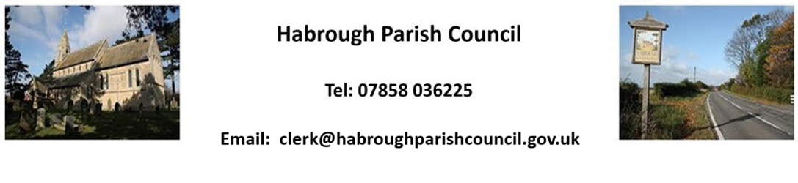

To All Habrough Parish Councillors
You are Summoned to a meeting of Habrough Parish Council on Monday 5th October 2026 at the Village Hall, Habrough at 7.30pm

Mr S. Brookes
Clerk to Habrough Parish Council – 27.09.2026

Please inform the Clerk/Chairman if you are unable to attend

The meeting will have a period of public consultation which shall not exceed 20 minutes in total. The public can speak on items contained on the Agenda below or on other issues of concern, although if these are not scheduled Agenda items the Council may have to carry the item and/or any action to the next meeting.
Note that the recording of meetings is allowed but only through prior notiﬁcation to the chairman and/or the clerk before the meeting commences and must be in accordance with the council’s adopted policy for such.

AGENDA

26/095 To receive and accept apologies for absence Apologies from –
In attendance:-

26/096 DECLARATIONS OF INTEREST (Code of Conduct 2020) –
- To record declarations of interest by any member of the council in respect of the agenda items listed below. Members declaring interests should identify the agenda item and type of interest being declared.

- To note dispensations given to any member of the council in respect of the agenda items listed below.

26/097 Minutes
To approve minutes of the last meeting from 7th September 2026

26/098 Reports by Ward Councillors
To receive brief reports from the Ward Councillors representing Habrough and the local community.

26/099 Highways/Footpaths/Traffic Issues
- To receive any updates on recent issues, receive any highways/footpaths matters and agree any necessary actions

26/100 Planning Matters

Awaiting email planning department

26/101 Reports
To receive reports from:
- ERNLLCA – non received at time of sending out

26/102 Parish Council Matters

26/103 Finance
- To receive Bank Statement and Bank Reconciliation for September 2026
- To approve any September payments as necessary

26/104 Any Other Business

26/105 Future Dates
- Next Parish Council Meeting – Monday 2nd November 2026

S.B./ 27.09.2026

